Copying ClassFinder Results to Microsoft Word: A Tutorial

First version: 12 February 2016

Last updated: 17 November 2021

Written by Jamie Heaney

Enterprise Application Services | ITS

1. Go to ClassFinder ([www.stthomas.edu/classes](http://www.stthomas.edu/classes)) and run your search. This example will use ESCI, but it works for anything.
2. When you get your search results, click “Table View (for Faculty/Staff)”. This converts the new display into a grid very similar to the old ClassFinder:

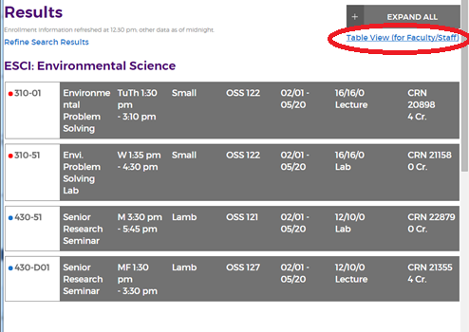

1. Highlight all the courses and copy them to your clipboard (usually by pressing CTRL-C). The search results should be collapsed (no visible course descriptions) before you do this. Also: make sure you are highlighting only the courses themselves, not the headers like “ESCI: Enviornmental Science.”

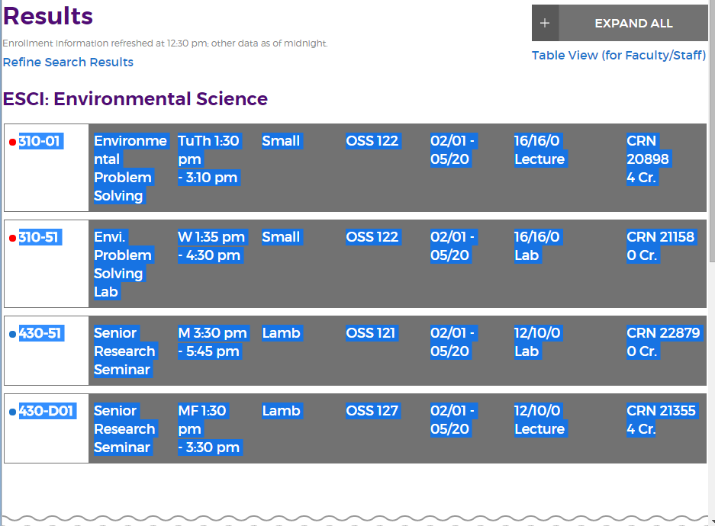

1. Open a new Microsoft Word document and open the Paste menu. Select “Merge Formatting” (the middle option):

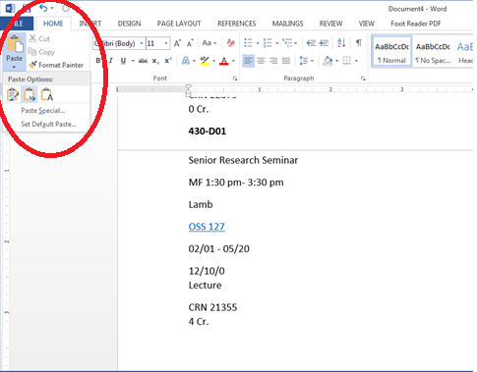

1. Select all text in the document. (You can click-and-drag to highlight everything, or just hit CTRL-A—but make sure that you don’t highlight any extraneous spaces at the end, or Word will interpret it as an extra cell!). Then select the Insert tab on the top ribbon menu:

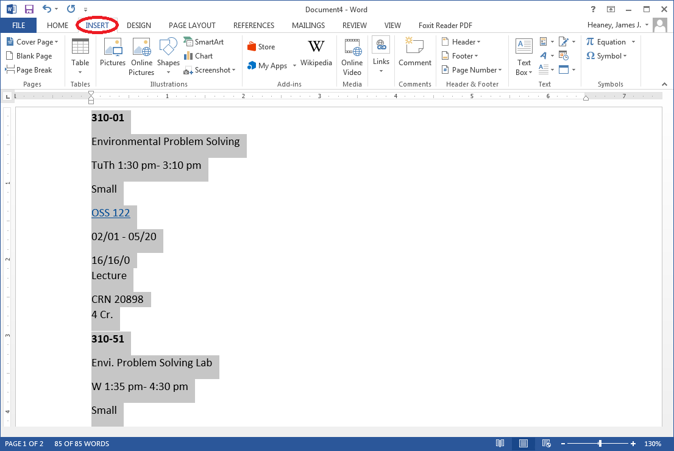

1. Click the Table menu, then select “Convert Text to Table…”:

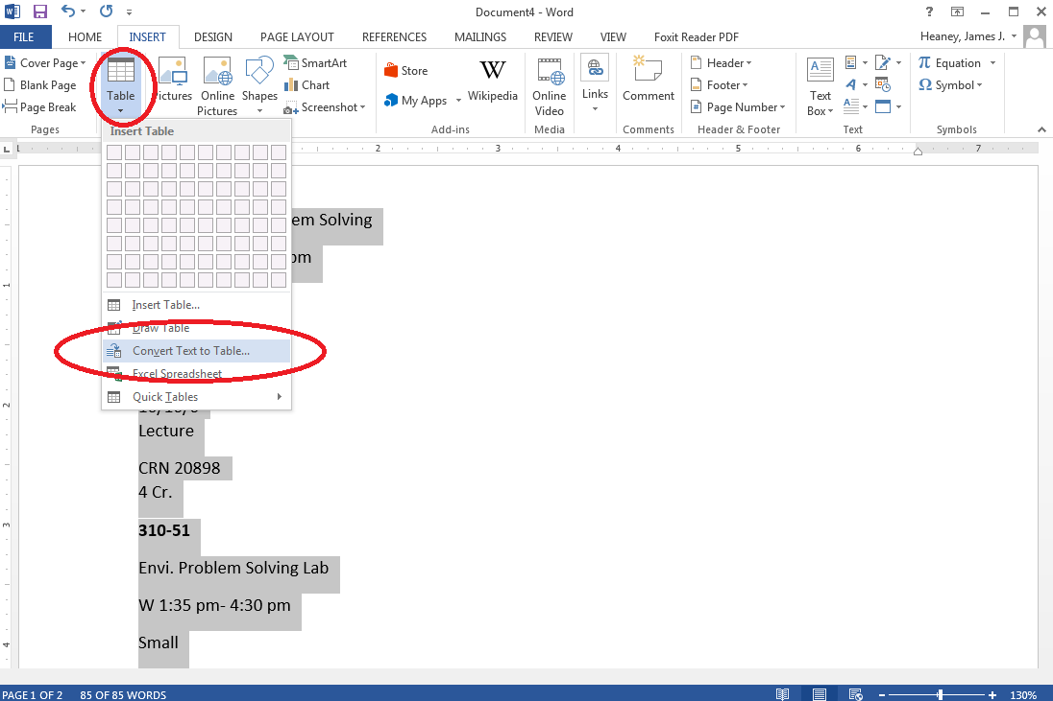

1. Change the number of columns to 9. The number of rows will be computed automatically, and should match the number of course-sections in the document. Everything else should be fine by default. Press “Ok.”

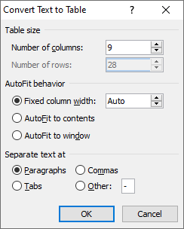

1. Word converts your text to tables.

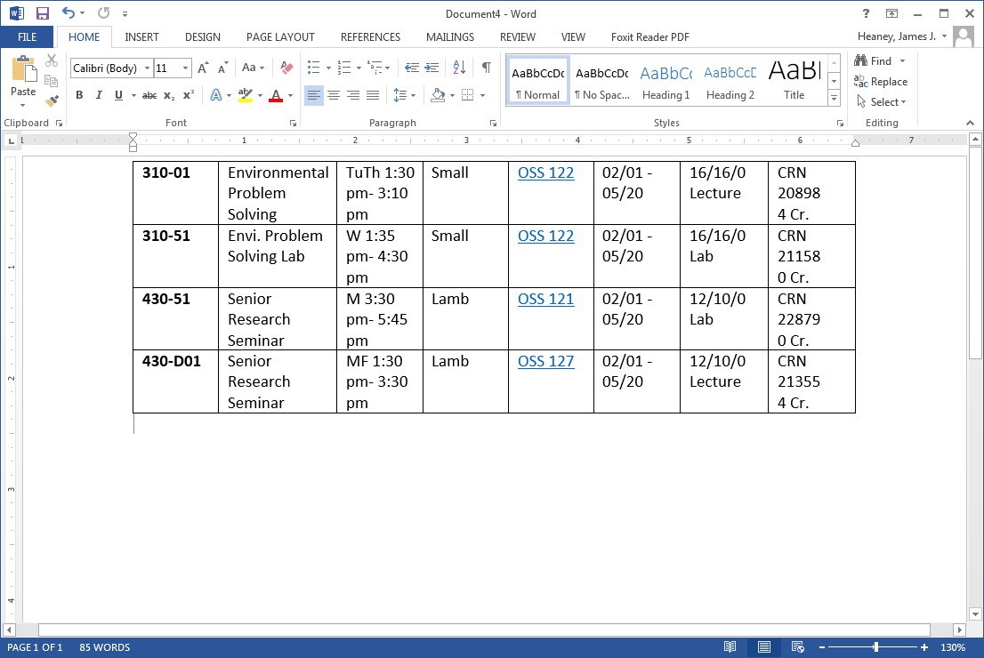

1. There may be an extra column, which is blank. Feel free to delete this column. To do this, right-click one of the blank spaces, press “Delete cells…”, and then Delete Entire Column. Then press OK.

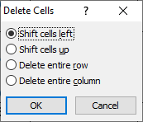

1. You can further adjust the column widths to your liking by using the ruler at the top of the page. Click-and-drag the column breaks to wherever feels best to you.



1. That should just about do it! Based on our discussions with various stakeholders, Enterprise Application Services believes this covers *most* tabular uses of ClassFinder. If you’d like to do anything further, you’ll probably want a Cognos report. Contact Institutional Data and Reporting ([IDAR@stthomas.edu](mailto:IDAR@stthomas.edu)).